Digital Transformation - Program Stakeholder Management Plan
Program Management Plan

Introduction

Purpose
The Stakeholder Management Plan is required to identify the people, groups and organizations that could affect or be affected by the Program, to analyze stakeholder expectations and their impact on the Program, and to develop appropriate strategies and tactics for effectively engaging stakeholders in a manner appropriate to the stakeholders’ interest and involvement in the Program. The Stakeholder Management Plan helps ensure that stakeholders are effectively involved in Program decisions and execution throughout the lifecycle of the Program, to gain support for the Program and anticipate resistance, conflict, or competing objectives among the Program’s stakeholders.

Overview
The Program team will create and maintain a Program Stakeholder Register that identifies all Stakeholders that are either directly impacted or will be engaged as part of the Program. This Register will be developed by the Program Manager (or delegate), as well as reviewed by the Program Owner to ensure completeness of the Stakeholder identification and engagement strategy defined.

Roles & Responsibilities

Executive Sponsors
The stakeholder management responsibilities for the Executive Sponsors are to:
- Be a positive Program champion to stakeholders;
- Support the Program to identify events or conditions (risks), in Business Operations or through Program Engagement, which could have a positive or negative effect on the Stakeholder Management Plan or Stakeholder Register;
- Assign Business Subject Matter Experts to work with the Program Manager on creation, review and approval of Program Deliverables. In addition, provide backups and/or replacements as required to cover Business Unit Brown-out periods, staff turnover and vacation schedules; and
- Assign other resources, as required, to support additional Program activities.

Business Subject Matter Experts
Business Subject Matter Experts (SME) are identified subject matter experts working within the business who are engaged with Program resources on providing detailed business, functional, and process requirements to support Program deliverables. Appropriate Business SMEs will also be identified to review and/or approve Program deliverables.
The stakeholder management responsibilities for the Business SMEs are to:
- Ensure stakeholders are aware of the Program; and
- Provide list of known stakeholders for the Stakeholder Register.

Program Owners
The stakeholder management responsibilities of the Program Owners are to:
- Ensure stakeholders are aware of the Program;
- Plan the approach with the Program Manager on the review of the Stakeholder Management Plan;
- Review and sign-off the Stakeholder Management Plan;
- Provide list of known stakeholders for the Stakeholder Register; and
- Work with the Program Manager to identify which Stakeholders are required for review and approval for each of the Program deliverables.

Program Manager
The stakeholder management responsibilities of the Program Manager are to:
- Solicit information from Program team members to identify the stakeholders in the Stakeholder Register;
- Create and attain approval for this Stakeholder Management Plan.
- Track and update all stakeholders in the Stakeholder Register.
- In coordination with the Program Owners, identify which Stakeholders are required for review and approval for each of the Program deliverables.

Stakeholder Identification
To identify stakeholders, the following avenues will be used:
- Review of the Stakeholders identified during the New Initiative / Change Risk Assessment Process (NI-RAP)
- Review of the Stakeholder Management List to identify Business Primes and Owners
- Solicit information from the Program Sponsor and Business Lead
- Confirmation at the Program Kickoff Meeting

The following criteria will be used to determine if an individual will be included as a stakeholder:
- Will the person or their department be directly or indirectly affected by this Program?
- Does the person or their organization hold a position from which they can influence the Program?
- Does the person have an impact on the Program’s resources (material, personnel, funding)?
- Does the person or their department have any special skills or capabilities the Program will require?
- Does the person potentially benefit from the Program or are they in a position to resist this change?
Any individual/department who meets one or more of the above criteria will be identified as a stakeholder.

Stakeholder Analysis
Stakeholder Analysis is used to categorize the stakeholders to determine the level of power and interest in the Program and to determine the appropriate levels of communication and participation in the Program.
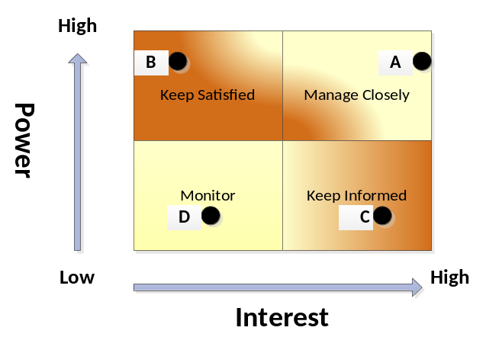.
Based on the stakeholder analysis above, the stakeholder communication and participation is as follows:
Stakeholder | Quadrant | Engagement Strategy
A | Manage Closely | Report progress on a regular basis typically via Program Status meetings, solicit stakeholder as a member of the Program Executive Steering Committee, provide regular Status Reports and address all concerns is imperative.
B | Keep Satisfied | Report progress on a regular basis typically via Program Status meetings, provide regular Status Reports, address concerns and resolve issues in a timely basis
C | Keep Informed | Provide communications/updates at key milestones and more frequently when the schedule is closer to the Go-Live date.
D | Monitor | Periodic communications as required.

